

13 July 2022

**Terra Industrial New Zealand Ltd**

PO Box 16 168

16 Branston Street, Hornby

Christchurch 8441, New Zealand

03 983 2333 Tel

www.TerraCat.co.nz

**Cancelling Quotations**

Search for the service call then select service segments

Select the segment > related info > call quotations

Select the quotation that says “**created”** > cancel quotation

Put in the reason of **“INVALID”** > OK

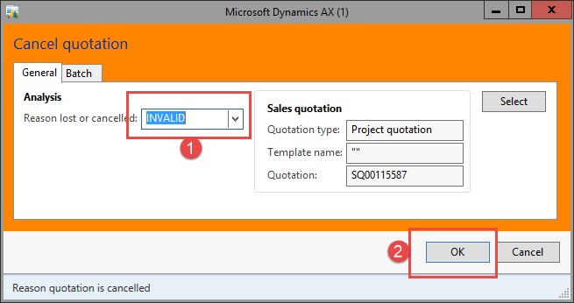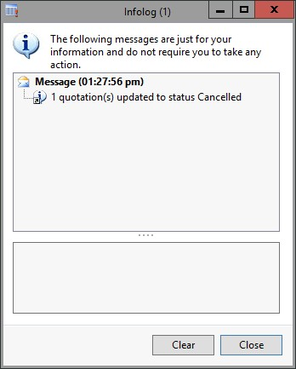

Close the quotation window and go back to the service segments

Expand “**Items**” > select all lines > select remove

Expand **“Hours”** > select all > select remove

Expand **“Misc Items”** > select all > select remove

Expand **“Misc Costs”** > select all > select remove

Go to the service segments tab > cancel segment

Repeat the above steps for EACH segment on EACH service call